Name : Kartik Velede

Student Number : 8672807

Assignmnet : Creating and pouplating Food budget list views

1. Below is the link and the screenshot for does not meet goals view

<https://conestogaecm.sharepoint.com/sites/ECM1466/F19/Kvelede2807/Lists/Food%20Budget/Does%20not%20meet%20goal.aspx>

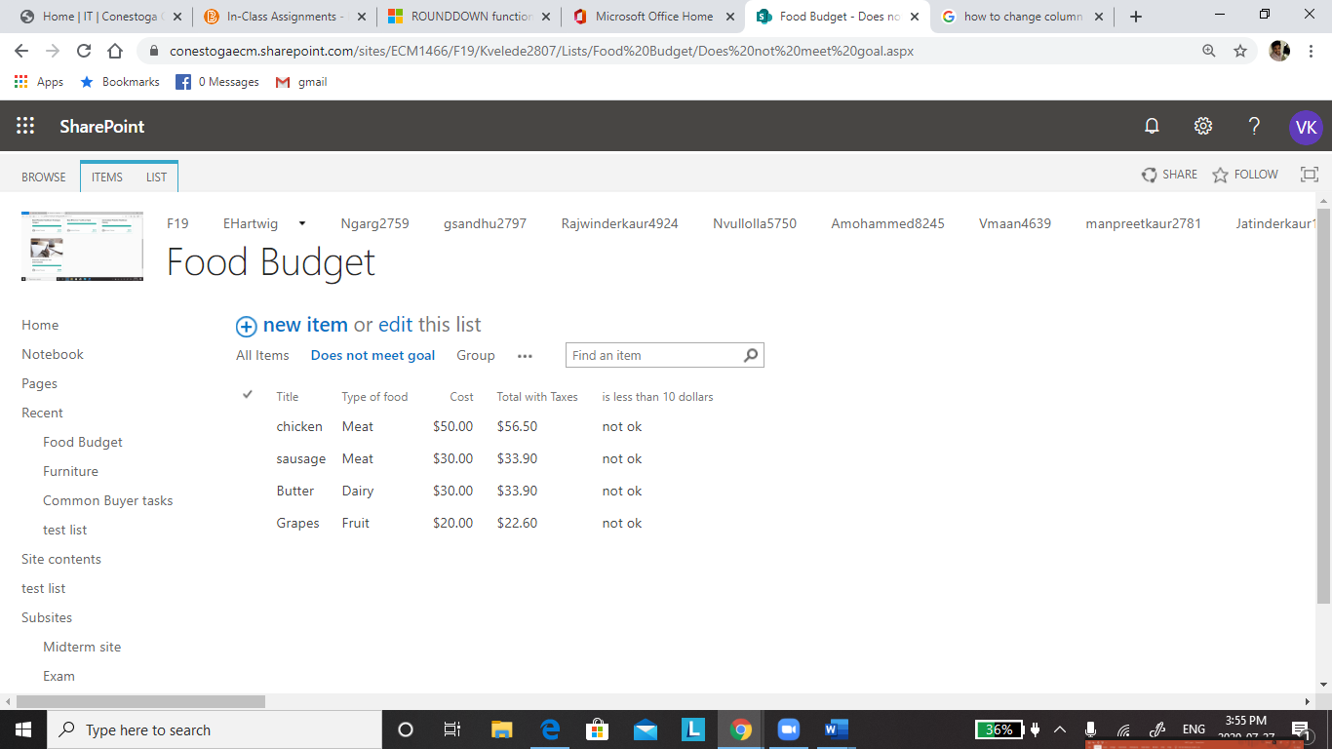

1. Below is the link and the screenshot for meet goals view

<https://conestogaecm.sharepoint.com/sites/ECM1466/F19/Kvelede2807/Lists/Food%20Budget/Meet%20Goals.aspx>

